**SQL HANDSON 1**

**NAME – ASHI JAIN**

**BATCH – IBM .NET**

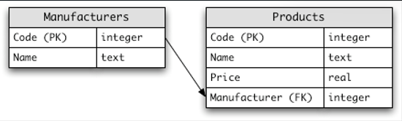

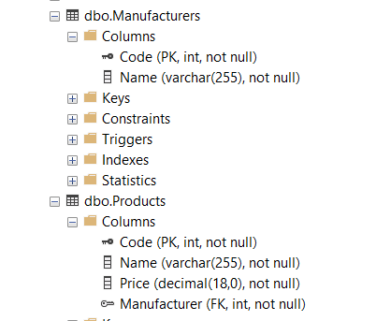

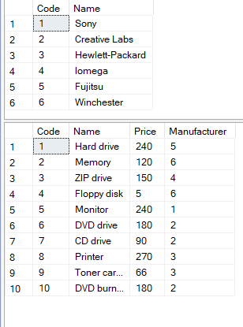

-- creating the database and initializing its name as Handson1.

create database Handson1

-- this command helps so that the table is present inside Handson1 folder and not inside the master folder.

use Handson1

-- creating the table name: Manufacturers

create table Manufacturers (

Code int primary key,

Name varchar(30)

)

-- creating the table name: Products

create table Products (

Code int primary key,

Name varchar(30),

Price int,

Manufacturer int,

constraint fk_manufacturer foreign key(Manufacturer) references Manufacturers(Code)

)

-- inserting the values into the Manufacturers table.

insert into Manufacturers values (1,'Sony')

insert into Manufacturers values (2,'Creative Labs')

insert into Manufacturers values (3,'Hewlett-Packard')

insert into Manufacturers values (4,'Iomega')

insert into Manufacturers values (5,'Fujitsu')

insert into Manufacturers values (6,'Winchester')

-- extracting all the values from the Manufacturer table.

select * from Manufacturers

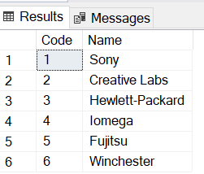

-- inserting the value into the Products table.

insert into Products values (1,'Hard drive', 240, 5)

insert into Products values (2,'Memory', 120, 6)

insert into Products values (3,'ZIP drive', 150, 4)

insert into Products values (4,'Floppy disk', 5, 6)

insert into Products values (5,'Monitor', 240, 1)

insert into Products values (6,'DVD drive', 180, 2)

insert into Products values (7,'CD drive', 90, 2)

insert into Products values (8,'Printer', 270, 3)

insert into Products values (9,'Toner cartridge', 240, 5)

insert into Products values (10,'DVD burner', 240, 5)

-- extracting all the values from the Products table.

select * from Products

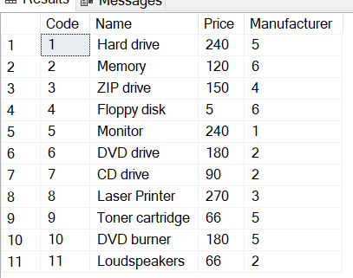

-- Q1) Select the names of all the products in the store.

select Name from Products

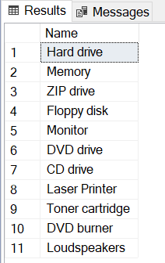

-- Q2) Select the names and the prices of all the products in the store.

select Name, Price from Products

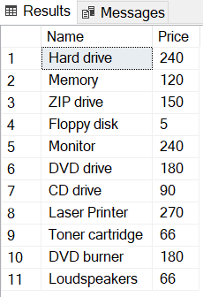

-- Q3) Select the name of the products with a price less than or equal to rs 200.

select Name from Products where Price <= 200

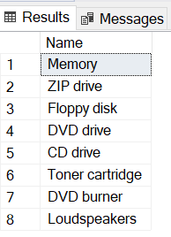

-- Q4) Select all the products with a price between rs 60 and rs 120.

select * from Products where Price between 60 and 120

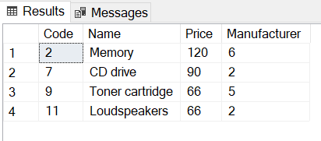

-- Q5) Select the name and price in cents (i.e., the price must be multiplied by 100).

select Name, Price*100 from Products

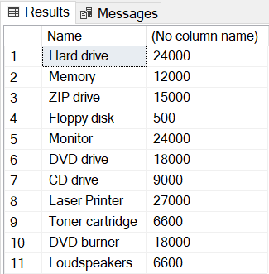

-- Q6) Compute the average price of all the products.

select avg(Price) as Average_Price from Products

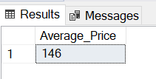

-- Q7) Compute the average price of all products with manufacturer code equal to 2.

select avg(Price) as Average_Price from Products where Manufacturer=2

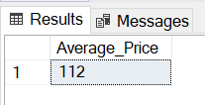

-- Q8) Compute the number of products with a price larger than or equal to rs 180.

select count(*) as Number_of_Products from Products where Price >= 180

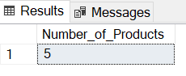

-- Q9) Select the name and price of all products with a price larger than or equal

-- to rs 180, and sort first by price (in descending order), and then by name (in ascending order)

select Name, Price from Products where Price >=180 order by Price desc, Name asc

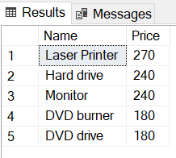

-- Q10) Select all the data from the products, including all the data for each product's manufacturer.

select * from Products p

full join

Manufacturers m

on p.Manufacturer = m.Code

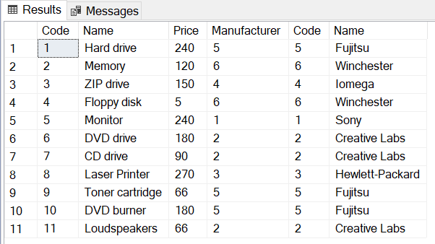

-- Q11) Select the product name, price, and manufacturer name of all the products.

select p.Name, p.Price, m.Name

from

Products p

inner join

Manufacturers m

on p.Manufacturer=m.Code

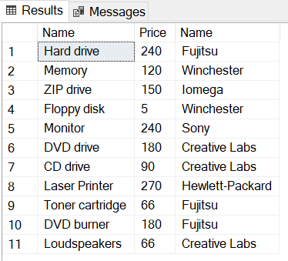

-- Q12) Select the average price of each manufacturer's products, showing only the manufacturer's code.

select AVG(Price) as Average_Price, Manufacturer

from Products

group by Manufacturer

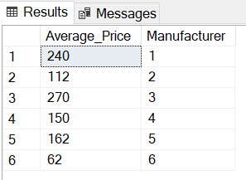

-- Q13) Select the average price of each manufacturer's products, showing the manufacturer's name.

select AVG(p.Price) as Average_Price, m.Name

from Products p

join

Manufacturers m

on p.Manufacturer = m.Code

group by m.Name

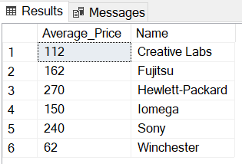

-- Q14) Select the names of manufacturer whose products have an average price larger than or equal to rs 150.

select AVG(p.Price) as Average_Price, m.Name

from Manufacturers m

join

Products p

on m.Code = p.Manufacturer

group by m.Name

having AVG(p.Price)>=150

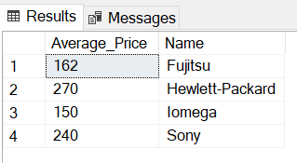

-- Q15) Select the name and price of the cheapest product.

select Name, Price from Products

where Price = (select MIN(Price) from Products)

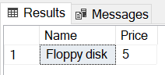

-- Q16) Add a new product: Loudspeakers, rs 70, manufacturer 2.

insert into Products values (11, 'Loudspeakers', 70, 2)

select * from Products

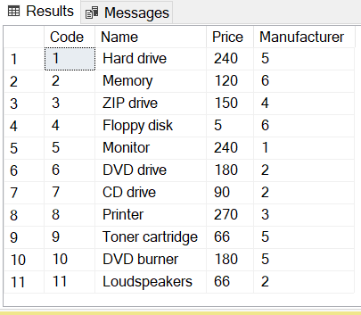

-- Q17) Update the name of product 8 to "Laser Printer".

update Products set Name = 'Laser Printer' where Code = 8

select * from Products

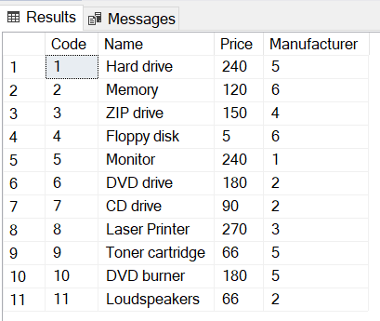

--Q18) Apply a 10% discount to all products.

update Products

set Price=Price*0.9

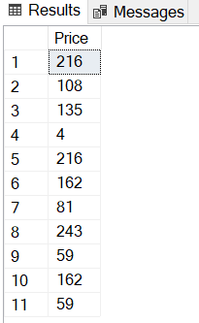

-- Q19) Apply a 10% discount to all products with a price larger than or equal to $120.

update Products

set Price = Price * 0.9

where Price >= 120;

